**Steam Boilers**

**STEAM BOILERS**

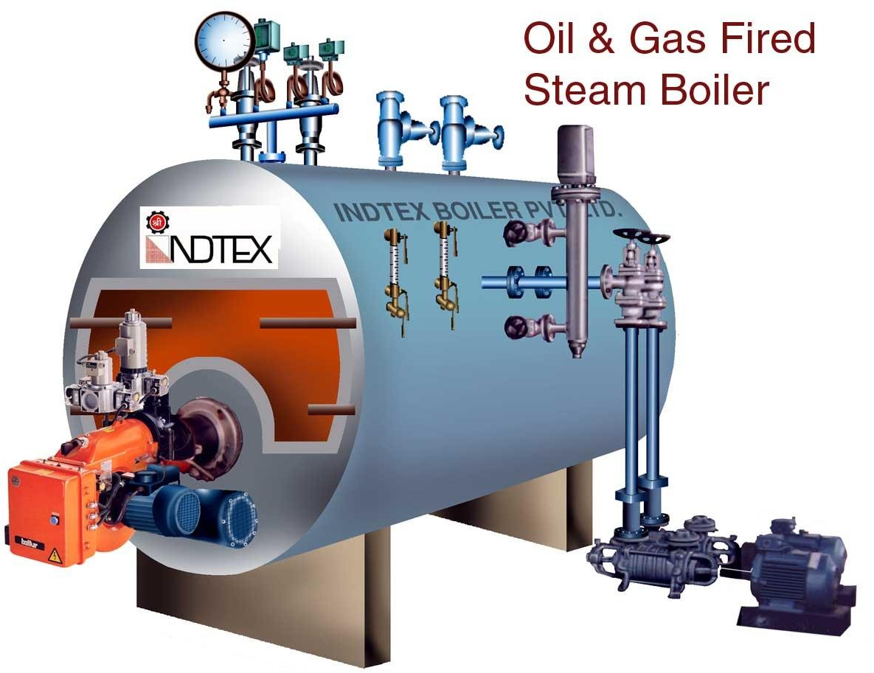

# Introduction

Various types of fossil fuels are the sources from which the heat energy is derived to produce the steam which in turn run the steam engines and the steam turbines. Steam is produced in a closed vessel called *boiler.* In practice the steam is used mainly for two purposes: (i) Power generation, and (ii) Process heating. In power generation, the steam is used to run the steam turbines in thermal power plants. As a process steam, it is used in textile industry for sizing and bleaching. It is used in paper mills for bleaching of the paper. It is also used for processing in chemical industries, sugar factories, pharmaceutical industries, breweries, etc.

# Definition of a Boiler

Boiler is defined as a closed metallic vessel in which the water is converted into steam above the atmospheric pressure by the application of heat generated by the combustion of fuels.

# Function of a Boiler

The function of a boiler is to supply the steam at the required constant pressure with its quality either dry, or as nearly as dry, or superheated. The steam can be supplied from the boiler at a constant pressure by maintaining the steam generation rate and the steam flow rate equal.

# Classification of Boiler

* + 1. **According to the axis of the shell:**
       1. Horizontal boiler
       2. Vertical boiler
       3. Inclined boiler

# According to the application

* + - 1. Stationary boiler
      2. Mobile boiler

# According to the location of the furnace

* + - 1. Internally fired boiler
      2. Externally fired boiler

# According to the type of fuel used

* + - 1. Solid fueled boiler
      2. Liquid fueled boiler
      3. Gaseous fueled boiler

# According to the method of circulation of water

* + - 1. Natural circulation boiler (circulation of water due to difference in temperature)
      2. Forced circulation boiler (pumps are used)

# According to the flow of water and flue gases

* + - 1. Fire tube boilers
      2. Water tube boilers

Boilers are classified based on the principle of working as: *(i) Fire tube boilers* and *(ii) Water tube boilers.*

# Fire Tube Boiler

In the fire tube boilers, the hot flue gases produced by the combustion of fuels are led through a tube or a nest of tubes around which the water circulates as shown in *Fig.* 2.1. The examples of this type of boilers are Cochran boiler, Cornish boiler, Lancashire boiler, Locomotive boiler and Scotch Marine boiler. Fire tube boilers are suitable for steady working pressures up to 20 bar.

Hot



**Water**

Hot

Gases In



Gases Out

Fig.2.1 Fire tube boiler

# Water Tube Boiler

In the water tube boilers, the water circulates inside the tubes while the hot gases produced by the combustion of the fuels pass around them externally as shown in *Fig.* 2.2. The examples of the water tube boilers are Babcock and Wilcox boiler, Stirling boiler, Yarrow boiler, etc. The water tube boilers are more suitable than the fire tube boilers for the generation of steam at very high pressures and also when the steam is to be raised quickly and in large quantity.

Cold

Water

In

Fig. 2.2 Water tube boiler

Cold

Water



|  |
| --- |
| **Gas** |
|  |
|  |
|  |
|  |
|  |
|  |

Out

# Babcock & Wilcox Boiler

Babcock and Wilcox boiler shown in *Fig.2.3* is a horizontal, externally fired, natural circulation, stationary water tube boiler*.* A high capacity boiler of this type can produce steam up to pressure of about 80bar.

Babcock and Wilcox boilers are used in thermal power stations for generating large quantities of steam at high pressures. This boiler is specially suited for thermal power stations, since it is capable of coping up very quickly for the sudden increase in pressure and steaming rate at high peak loads.

# Construction:

The Babcock and Wilcox water tube boiler shown in *Fig. 2.3* consists mainly four parts:

*(i) Water and steam drum, (ii) Water tubes (iii) Chain grate stoker, and (iv) Super heater tubes.*

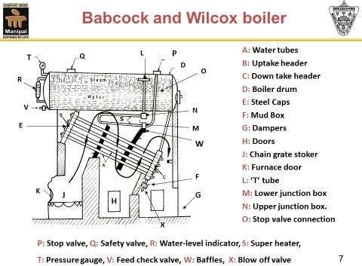

Fig.2.3 Babcock & Wilcox Boiler

The *water and steam drum is* suspended from *iron girders* resting on the iron columns, (not shown in figure) and is independent of the brick work setting. A number of *inclined water tubes* at a very low inclination are connected at right angles to the end boxes called *headers.* The water tubes will be arranged in. a number of vertical rows, each row consisting of 4 to 5 tubes. In each vertical row, the tubes are arranged one below the other. There will be number of such vertical rows one behind the other. Each one such vertical row of inclined water tubes are connected to one set of two headers. The header shown at the right end of the water tubes is called *down take header* and the other shown at the left end of the water tubes is called *uptake header.* Each of the vertical rows of water tubes which are arranged one behind the other are connected individually to one set of headers which are also arranged one behind the other. Each set of the headers are then connected to the boiler drum by a set of water tubes. A mud box is provided just below the down take header. Any sediments present in the water due to its heavier specific gravity will settle down in the mud box and is blown off from time to time through the *blow off valve.*

A *moving grate* is provided at the front end below the uptake header. The boilers of higher capacity are usually provided with a chain grate stoker, which consists of a slowly moving

endless chain of grate bar. The coal fed at the front end of the grate is burnt on the moving grate in the furnace and the residual ash falls at the other end of the grate into the ash pit.

This type of boiler is generally fitted with a *super heater.* The super heater consists of series of U-tubes secured at each end to the horizontal connecting boxes and placed in the combustion chamber underneath the boiler drum. The upper junction box of the super heater tubes is connected to a T-tube, the upper branch of the T-tube being situated in the steam space in the drum. The lower junction box of the super heater tubes is connected to the steam stop valve mounted over the drum through a vertical tube passing outside the drum.

## Function of chain grate stocker:

The speed of chain grate stocker can be adjusted according to the quality of the coal available, which in turn varies the time for the coal to reach the rear end from the front end thereby ensuring effective burning of the fuel.

## Water Circuit in the Boiler:

The water is introduced into the boiler drum through the *feed valve.* A constant water level is maintained in the boiler drum. The water descends at the rear end into the down take headers and passes up in the inclined water tubes because of reduction in density due to heating. The flow continues to the uptake headers and the drum. Thus a circuit is established between the drum and the water tubes for the flow of water.

## Path of the Flue Gases:

The hot gases from the furnace grate are compelled by the *baffle plates* to pass upwards around the portion of the water tubes lying be1ow the water drum in between the uptake header and the first set of baffle plate, then downwards around the portion of the water tubes lying in between the baffle plates, then once again upwards between the baffle plate and the down take header, and finally passes out of the boiler into the atmosphere through the exit door and the chimney.

## Circulation of the Water:

During this path of the hot gases, the hottest gases emerging directly from the grate come in contact with the hottest portions of the water tubes. The water in these portions of the water tubes gets evaporated. The water and the steam mixture from these portions of the water

tubes ascends through the uptake header and reaches the boiler drum. Now due to this flow, a continuous rapid circulation of water is established between the boiler drum and the water tubes. The steam gets separated from the surface of the water in the boiler drum.

## Superheating of the Steam:

The steam from the steam space in the boiler drum is led into the branches of T-tube, and then passes into the upper junction box of the super heater, then through its U-tubes. Since the super heater tubes are fitted in the combustion chamber and directly exposed to the hot gases, the steam passing in it will be superheated. The superheated steam from the super heater tubes are passed to the steam stop valve through the lower junction box and the vertical tube fitted outside the drum. From the steam stop valve the superheated steam is passed to the prime mover. When the superheated steam is not required, the steam from the steam space directly passes out to the prime mover through the steam stop valve. The boiler is mounted with the essential mountings such as steam stop valve, safety valves, blow off valve, feed check valve, pressure gauge and water level indicator as shown at their appropriate places.

# Advantages and Disadvantages of Water Tube Boilers over Fire Tube Boilers

## Advantages:

1. ***Steam can be raised more quickly:*** In water tube boilers, the ratio of water content to the steam capacity is comparatively less than the fire tube boiler. Hence water tube boilers can quickly generate steam at the required pressure than the fire tube boiler.
2. ***Steam at higher pressures can be produced:*** The water tube boilers do not contain any tubes inside the boiler drum. Hence the water tube boilers can withstand high pressures for the same wall thickness and the thermal stresses. Therefore, water tube boilers can develop higher pressures than the fire tube boilers.
3. ***Higher rate of evaporation:*** In water tube boilers, water is contained in a large number of small diameter tubes, therefore the heating surface of a water tube boiler is more than that of the fire tube boiler. The relatively large heating surface of the water tube boiler increases the evaporation rate. The increased rate of evaporation of the water tube boiler makes it more suitable for large power plants.
4. ***Sediment deposition is less:*** In water tube boilers, the circulation of water is more positive than that of the fire tube boilers; hence there is a less tendency of the deposits to

settle on the heating surfaces. This positive circulation also helps in the quick generation of steam as compared to a fire tube boiler.

1. ***Suitable for any type of fuel and method of firing:*** Since the water tube boilers are externally fired, the size and proportions of the furnace can be altered to suit any type of fuel.
2. ***More effective heat transfer:*** The heat transfer in the water tube boilers is more effective than the fire tube boilers since the hot gases flow at right angles to the water tubes.
3. ***Occupies less Space:*** For a given power output, water tube boiler occupies less space than that of the fire tube boilers.
4. ***Easy maintenance:*** All parts of the water tube boilers are easily accessible compared to, the fire tube boilers, for cleaning, repairing and inspection and hence maintenance is easy.
5. ***Easy transportation*:** Water tube boilers can be easily dismantled and conveniently transported and erected quickly at the site than a fire tube boiler.

## Disadvantages:

1. **Not suitable for ordinary water:** Water tube boilers require relatively pure feed water because impure feed water forms scales inside the water tubes, consequently there will be overheating and bursting of the water tubes.
2. **Not suitable for mobile application:** Water tube boilers are not suited for mobile purposes as they are externally fired.
3. **High initial cost and hence not economical:** The initial cost of water tube boilers is much more than that of the fire tube boilers.

# Differences between Water Tube and Fire Tube Boilers

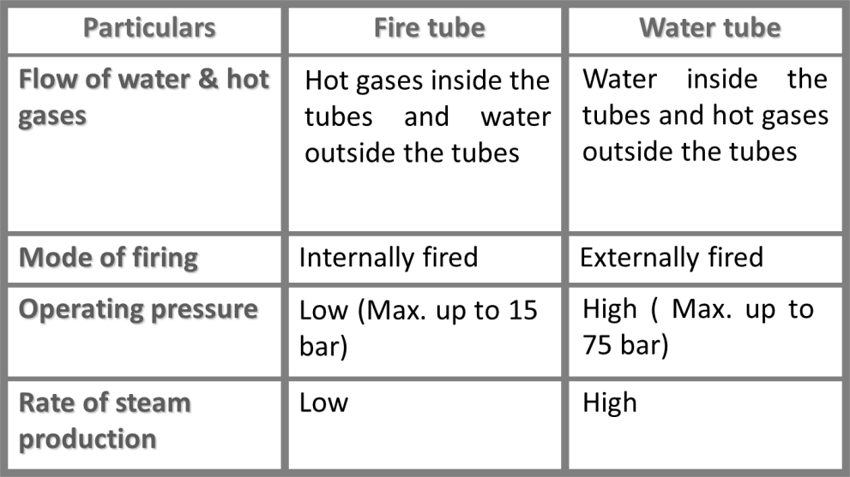

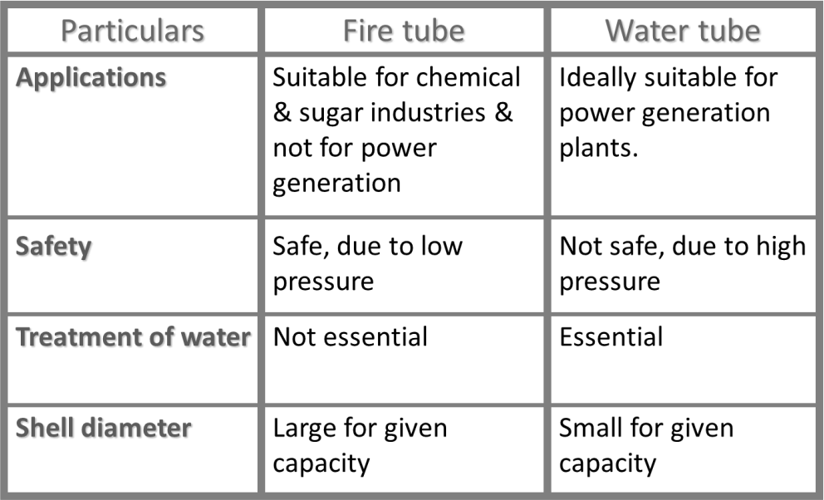

**\*\*\*\*\*\*\***

Boiler Mountings & Accessories:

For efficient functioning, easy maintenance and most importantly to ensure safety to the boilers, they have to be equipped with some types of fittings and appliances. These are called boiler mountings and accessories.

Boiler Mountings:

The first category of fittings called “Boiler Mountings” are required for controlling the steam generation, measurement of important steam properties and most importantly to provide safety to the boiler. These mountings are mandatory as per the boiler legislation and are fitted

directly on the boiler and become an integral part of the boiler. The essential boiler mountings are

1. Water Level Indicator
2. Safety Valves
3. Pressure Gauge
4. Steam Stop Valve
5. Blow Off Valve
6. Feed Check Valve
7. Fusible Plug
8. Man Hole & Mud Box
9. Water Level Indicator: Their function is to indicate the level of water in the boiler and thereby to guide the boiler attendant to maintain a constant level of water in the boiler. Every boiler shall be fitted with two level indicators so that one of them will serve as a standby if the other fails. The water level indicator has arrangements for automatically shutting off the steam and water supply to the indicator glass tube if the latter is broken due to any reason.
10. Safety Valves: The function of the safety valve is to prevent the steam pressure in a boiler from exceeding certain predetermined value. A boiler is designed to operate at a certain rated pressure called design pressure. However the operating pressure in a boiler is generally maintained below the design pressure. When the boiler is in operation either due to sudden reduced flow of steam out of the boiler or due to sudden increased rate of steam generation which may be due to low water levels or increased rate of combustion there will be a increase in steam pressure which poses danger to the safety of the boiler. This excess steam must be instantly released from the boiler to reduce the steam pressure. A safety valve instantly blows off the excess steam from the boiler and shuts off automatically thereby restoring the normal working pressure. There are different types of safety valves namely Dead Weight Safety Valve, Lever Safety Valve, Spring Loaded Safety Valve etc.
11. Pressure Gauge: The function of the pressure gauge is to indicate the pressure of the steam in the boiler. The pressure gauge is normally mounted in the front end at the top of the boiler drum so as to be clearly visible to the operator.
12. Steam Stop Valve: The function of the steam stop valve is to regulate the flow of steam from the boiler to the steam pipe or from one steam pipe to another. The valve has a handle whose rotation causes a spindle to move up and down, thereby opening and closing the valve fully or partially and varying the flow rate of steam.
13. Blow Off Valve: The function of the blow off valve is to remove the sediments collected at the bottom of the boiler periodically while in operation. It is also used to empty the water from the boiler drum for carrying out periodical cleaning and maintenance. It is fitted to the mud box which is located at the lower most part of down take header.
14. Feed Check Valve: Feed check valve is a non-return valve and performs the dual function of regulating the flow of water to the boiler drum and preventing the return flow of water from the boiler drum when the feed pump is switched off or in the event of failure of feed pump. It has two valves called feed valve and check valve. The check valve allows the water to flow only in one direction, i.e. from the feed pump to the boiler. The feed valve is operated by the handle controls the flow of water to the boiler.
15. Fusible Plug: Fusible plug is a safety device which is used to extinguish the fire in the boiler furnace when the water level in the boiler falls too much below the normal level. It is fitted on the bottom most portion of the boiler drum just above the combustion zone. The plug has an annulus of fusible metal having low melting point. Normally the plug is covered by water inside the boiler drum which keeps the temperature of the plug below its melting point. As the water level falls below the minimum level the plug is uncovered and the fusible metal melts as it gets exposed to steam space instead of water, which is not able to keep it cool. The plug drops down and the steam present in the boiler drum rushes out into the combustion zone and puts out the fire.
16. Man Hole & Mud Box: Manhole is an elliptical opening on the top portion of the boiler large enough for a person to go inside the boiler drum for cleaning and inspection purpose.

Mud box is located at the bottom portion of the down take header for collecting the mud particles present in the water. The blow off valve is connected to the mud box.

Boiler Accessories**:** The second category of fittings used in the boiler assembly are Boiler Accessories which are meant to improve the efficiency of the boiler and hence the power plant. These are fitted outside the boiler drum and are not mandatory. The essential boiler accessories are

1. Economizer
2. Air Preheater
3. Superheater
4. Steam Separator
5. Steam Trap.
6. Economizer: The function of the economizer is to increase the temperature of the feed water. The flue gases coming out of the combustion zone of the boiler possess substantial amount of heat energy which otherwise would go as waste if it is let out to the atmosphere through the chimney. These gases can be utilized for pre heating the feed water so as to increase its sensible heat which in turn reduces the fuel consumption in the boiler thereby improving its efficiency.



1. Air Preheater: Air pre heater is an accessory which is used for preheating the air supplied to the furnace grate. Supply of preheated air accelerates the combustion process, leading to faster and complete combustion of coal thereby improving the thermal efficiency of boiler. It is generally installed between the economizer and the chimney.



Atmospheric air entry

Pre-heated

air supply to boiler furnace

Ref: https://www.tlv.com/global/TI/steam-theory/mechanical-steam-traps.html

1. Superheater: It is used to increase the temperature of the steam beyond the saturation temperature by supplying additional heat thereby increasing its enthalpy. It consists of a set of tubes through which steam passes from the steam space of the boiler. It generally receives heat from the flue gases leaving the furnace.

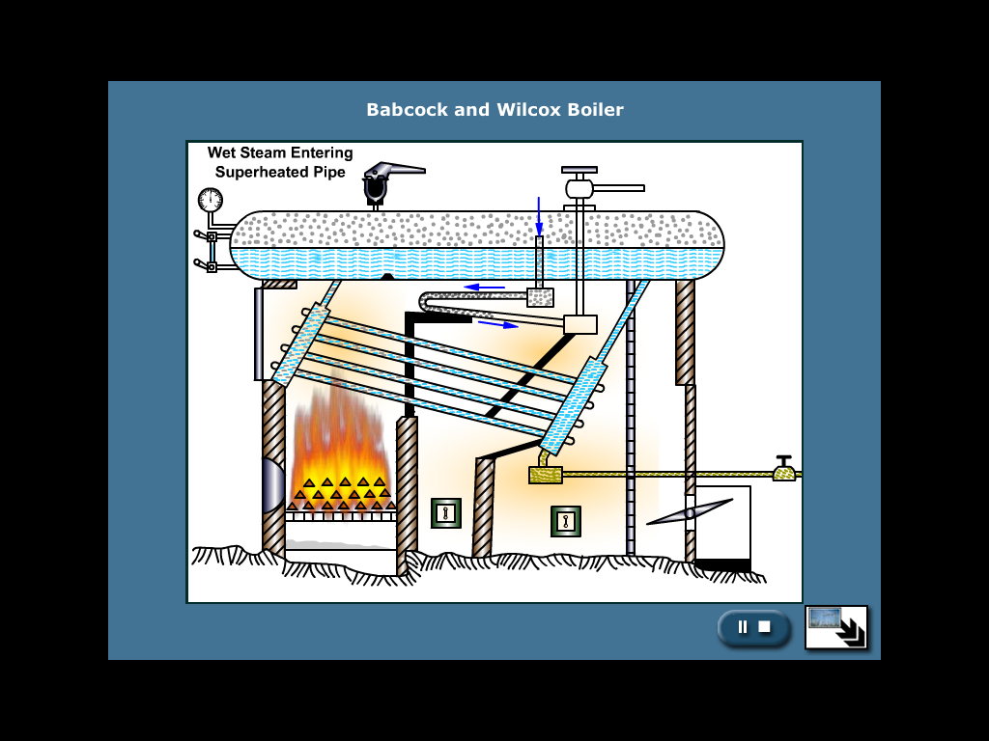

There being a continuous passage between the boiler steam space and the interior of the superheater, there can be no change in the steam pressure due to superheating. It thermal power generation it is necessary to use superheated steam so as to avoid condensation and corrosion of turbine parts.

1. Steam Separator: Steam separators are used to separate entrained water particles from the steam flowing in the pipe lines, since the use of wet steam in a steam turbine has many disadvantages. It is installed very close to the steam turbine.



Ref: https://www.tlv.com/global/TI/steam-theory/mechanical-steam-traps.html

1. Steam Trap: Steam trap is an accessory that is used to drain off the condensed water accumulating in the steam pipe lines or steam separators, while at the same time ensuring that the high pressure steam does not escape out of it. It is connected to a bypass pipe which branches off from the main steam pipe line and has a mechanism to automatically discharge the accumulated condensed water.

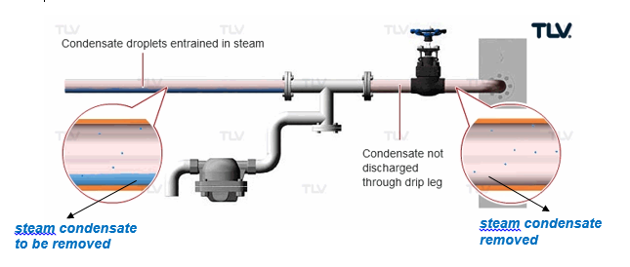

Ref: https://www.tlv.com/global/TI/steam-theory/mechanical-steam-traps.html

***Steam trap***